User Instructions For PDTP

Programming software for
Paging Data Terminals (PDTs)
Paging Data Receivers (PDRs)
Paging Serial Receivers (PSRs)

Installing the software

PDTP requires a PC running Windows 2000/NT/XP and at least 32MB RAM.

- Unzip the installer PDTP.zip to a temporary file or open the installer files in Winzip.
- Run the installer by double clicking on Setup.exe.
- Follow the instructions in the installer wizard.
- Once installed run PDTP by clicking on the shortcut or selecting esp.exe from the folder in which it is installed.
- You will be prompted to Enter Set ID . The key will have been provided to you or may be contained on the CD in a notepad file called PDTP Key.txt.
- Hit OK.
- If your key permits access to more than one Template then a selection of templates will appear in a new window. If your key only allows access to one template then PDTP will start automatically in that template.

{Note: templates determine the function of the PDT/PDR e.g. Flex or pocsag, PDT or PDR etc.}

Connecting the PDT/PDR

Required Items: *1 x Serial Null Modem DB9 female-to-female cable.
*1 x 12v DC Power supply rated at 0.5 amps (or greater) with 2.5mm center positive plug attached.

- Plug the serial cable into the PC (COM1 is the default port)
- Open PDTP
- Select the template appropriate to the PDT/PDR/PSR that you are programming. Note if you only have a key for one template then PDTP will open automatically with that template active.

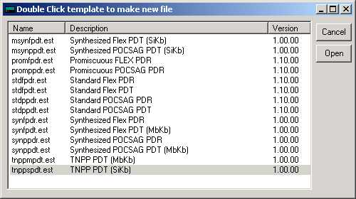

- Plug the PDT/PDR into a 12-volt supply and plug in the DB9 plug into the back of the PDT/PDR.

{PDTP does not read or write to the PDT/PDR unless instructed to do so. It is recommended that unless you need to change the basic template of the PDT/PDR then you download the settings from the unit first. Click on the “Download From Pager” button. This will download the current settings from the PDT/PDR. It will also ensure that the template was selected correctly. The template will change to that contained in the PDT/PDR if it was not selected correctly when you opened PDTP.

If you need to change the basic template of the PDT/PDR do not do a download. Just select your template, change the settings and press “Upload To Pager” (Please consult }

The Main PDTP Window

Note the main window will look slightly different for different templates e.g the PDR templates include a button for alert settings and setting the time.

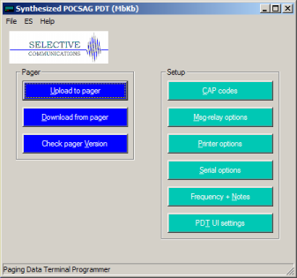
Title Bar
The blue Title Bar at the top shows the current Template selected.
Upload To Pager Button
This button is used to upload new settings to the PDT/PDR. This will overwrite any settings currently in the PDT/PDR.
Download From Pager Button
This button is used to download the current settings from the PDT/PDR. This will overwrite any settings currently in PDTP and will change the template in PDTP to that programmed in the PDT/PDR if different from that showing.
The Set Time & Upload Button (PDR & PSR Templates Only)
This button is used to set the time and upload the new settings to the PDR2000. Time is set on the PDT in the PDT User Interface.
Menu Options
File – New Open, Save, Save As
Open, save or create new configuration files which are saved as .ses files.
File – Set Template
Change the current template. (This option is only available if you are authorized for more than 1 template option.)
File – Set Template Set ID
Change the key that authorizes the templates available. (This option is only available if you are authorized for more than 1 template option.)
File - Comport
Change the comport to which the PDT/PDR is connected.
ES – Read, Write
Read and write configuration settings to and from the PDT/PDR. These are the same as the Upload and Download Buttons on the mainscreen (see below)
ES- Upgrade
Use this option to upgrade the Flash ROM in the PDT/PDR. Only use this option if instructed to do so by a service representative.
ES – Set Time & Write
Set the time and write configuration settings to and from the PDT/PDR. This is the same as the Set Time and Upload button on the mainscreen (see below)
Import Capcodes
Provides the capability to load a large number of capcodes from a .csv file. Note currently this only permits the loading of the capcodes and names and does not set the output settings which must be done manually.

The Capcodes Window

This window is used to set the capcodes (addresses) and the output settings for each capcode.

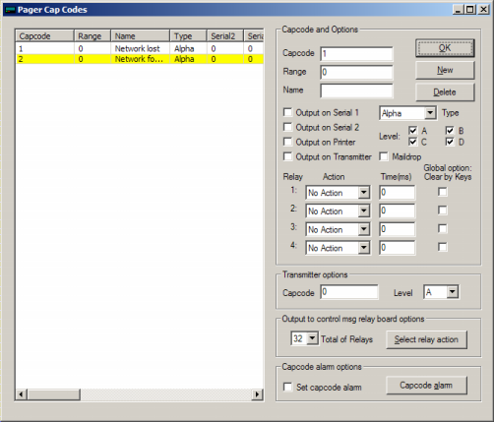

Adding Capcodes (Addresses)

- Enter a new CAP code by clicking on the “New” Button.
- Enter the new CAP code in the “Capcode” box and the name in the name box below. i.e., 1234567 TEST CAP. The name is just an identifier and is not compulsory.
- If a range of capcodes is required then select the first capcode and the range that you wish to monitor e.g entering capcode 1000000 and a range of 50 will monitor capcodes 1000000 to 1000050.
- Set each of the desired outputs individually for each capcode by highlighting the capcode in the Left hand window and then selecting the outputs on the Right.

Output Options
Serial 1 The message received on this address will output on serial 1 – Set serial options (global) in the Serial Options window.
Serial 2 The message received on this address will output on serial 2 – Set serial options (global) in the Serial Options window.

Print The message received on this capcode will be output on the Printer port (parallel printer) or Serial 1 (serial printers). Global print options are set in the Printer Options window.
Maildrop Sets this address as a maildrop capcode. Messages will be stored and overwritten automatically in the Maildrop area of the display and will not be stored in the normal messages area.
Type This option allows the type of message received to be set. In Flex Templates the options are Alpha, , Alpha Warning and Alpha Watch. In pocsag the tone and numeric options are added.
Note: Alpha Warning and Alpha Watch are special settings that allow different initial alerts to be set for messages received on that capcode.
Level Sets the pocsag levels for the capcode
Relays 1-4 Sets the action that will occur on each of the 4 on board relays on receipt of any message on that capcode. Relays are Normally Open.
Options are
          - Close Relay
          - Open Relay
          - Momentary Close Relay for a period (in msecs)
Global Option Clear By Keys If selected any relay action initiated on the selected relay, by any capcode, will be cancelled (reset to normal condition) by hitting any key (PDT2000 only).
Output to Control Relay Board This sets the actions of any one or more of the relays contained on the RCM2000 module. Each RCM2000 adds 32 additional relays and may be daisy chained.
Output to Transmitter When a transmitter is connected this sets the output capcode and pocsag level to which the message received on this address will be transmitted in pocsag.
Capcode alarm Triggers an output event if no transmissions are received on the selected capcode in the selected period of time (alarm interval - in msecs.
The Msg Relay Options Window

This window is used to set global relay control actions according to the text contained in a message received on the selected capcodes. Up to 128 actions may be set for the PDR and PSR and 80 for the PDT.

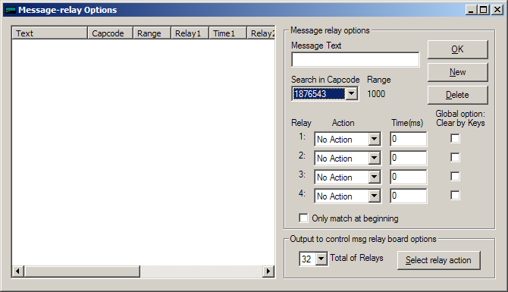

Setting up a Msg Relay action:

- Select New
- Enter the text that you wish a relay or relays to activate on.
- Select the capcodes to which this action will apply i.e. All or one from the drop down list. Note any capcodes entered in the main screen with a range attached will apply that action across the whole range.
- Select the relay actions to apply when that text is received by the capcodes selected.

Options:

Global Option Clear By Keys If selected any relay action initiated by any Message Text will be cancelled (reset to normal condition) by hitting any key (PDT2000 only).

Only Match At Beginning Only text at the beginning of the message will be matched with the target text.

Output to Control Relay Board Extends the capability of this function to the relays on the optional relay control modules (RCM2000).
The Printer Options Window

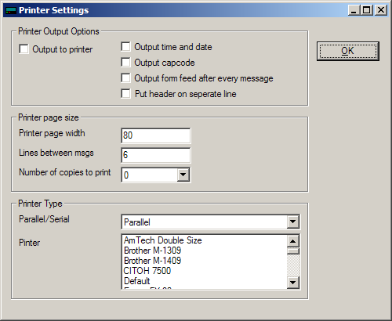

Output Options

Output to Printer Turns printing on (global option). (Note printing still needs to be set for each individual capcode in the Capcodes window.
Output Time & Date Outputs Time & Date to Printer.
Output Capcode Outputs Capcode to Printer.
Output Form Feed Outputs a Form Feed to Printer.
Put Header on Separate Line Puts the Header (Date/Time, Capcode) on the first line followed by the message after a line feed.
Printer Page Width Set the width of the paper
Output Lines Between Messages Outputs a selectable number of line feeds following each message.
Number of copies to print Sets the number of times the same message is printed.
Printer Type Set printer type as parallel or serial (See PDTP Serial Printer Setup document).
Printer Contains a number of common printer drivers.
The Serial Options Window

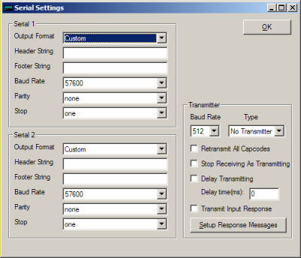

Output Format Contains a number of standard settings for serial output options to commonly used equipment and software applications.

Header String Sets the header string at the beginning of the serial output.

Footer String Sets the footer string at the beginning of the serial output.

Some standard settings for header and footer strings are:
\r CR, Carriage Return
\n LF, Line Feed
\r\n new line
%n name of address
%a address in decimal
%p protocol
%m message type
%b baud rate in decimal
%L alpha level
%T 24 hour time
%y day, month
%Y day, month, year
For example: \r\n Name:%n Capcode:%a Protocol:%p Time:%T Date:%y\r\n

Transmitter Output

Contact Selective for instructions on the set up of transmitter output from this window.

The Alert Options Window (PDR2000 Only)

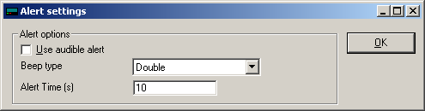

This window appears only in PDR templates. (Alerts are set in the PDT via the PDT user interface).

It is used to turn audible alerting on and off and set the type and length of the audible beep.

The Frequency & Notes Window

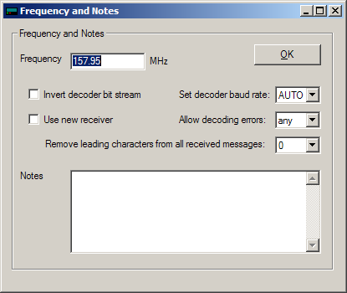

Frequency Set the synthesized frequency. Note: the frequency must be within the frequency band of the receiver supplied. This will normally be noted in the Notes section.
Invert Decoder Bit Steam Use this if your pager is set to data inverted. Consult your carrier before using this option.
Set Decoder Baud Rate Use to set the baud rate (pocsag only). This may be set to auto although better performance may be experienced if all pagers are on one baud rate and the unit is set to that baud rate.
Use New Receiver Please consult with Selective before changing this option. A new receiver is being progressively introduced from Q3 2005. On the PDT2000 an RSSI (Received Signal Strength Indicator) will appear on the display when the new receiver is in use.
Allow decoding errors Selects the number of character errors that the receiver will accept before it discards (ignores) the message.
Remove leading characters Removes the selected number of leading characters in a message before it outputs the message or applies any message filters. This is used to ignore special characters used by some systems for special decoding options.
Notes An area to make general notes on this unit. This information is stored on the PDT/PDR so that it can be read wherever the unit is programmed.
The PDT UI Settings Window

This window will appear in the PDT2000 templates only. It is used to set standard User Interface settings that are normally set by the user via the PDT2000 display.

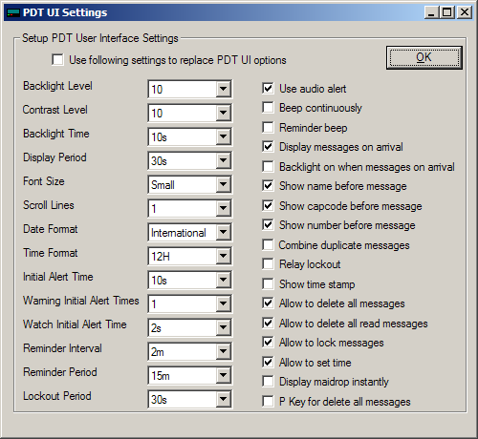

Use the following settings If this box is checked the settings will be settable only from PDTP and not from the PDT2000 user interface. (Except Backlight and contrast levels and the date and time).
Settings

Display Options
Function | Description | Settings
Backlight Level | Sets the initial display backlight level | 1-20
Contrast Level | Sets the initial display contrast level | 1-20
Backlight Time | Set how long backlight is to remain on after key press | 5s/10s/30s/1m/5m/Permanent
Display Period | Set the amount of time the message will display for before reverting to main screen. | 5s/10s/30s/1m/5m/Permanent
Font Size | Sets the size of the message font on the display. | Small, medium, large
Scroll Lines | Sets the number of lines to scroll when the down button is pushed when a message is displayed. | 1,3
Date Format | Display dates mm/dd/yy or dd/mm/yy | US or International
Time Format | 12 or 24 hour | 12 or 24
Initial Alert Time | How long beeper sounds on initial receipt of message | 1s/5s/10s/30s/1m/ 5m
Warning Initial Alert Time | How long beeper sounds on initial receipt of a message on a Warning capcode. | 0,1s,2s,3s,4s,5s,10s,30s,60s,300s  (See capcode settings for an explanation of the Warning type)
Watch Initial Alert Time | How long beeper sounds on initial receipt of a message on a Watch capcode. | 0,1s,2s,3s,4s,5s,10s,30s,60s,300s (See capcode settings for an explanation of the Watch type)
Reminder Interval | How often the reminder beep sounds - every | 30s/1m/2m/3m/4m/5m
Reminder Period | How long reminder beep continues for | 5m/10m/15m/30m/Forever
Lockout period | The period during which no additional activations of relays shall occur given the same activation instruction. | 0,1s,2s,3s,5s,10s,20s,30s,1m,2m,3m,5m,10m,20m,30m
Audible Alert | Beeper sounds on receipt of message | On or Off
Beep Continuously | Beeper sounds until message is acknowledged by pressing any key | On or Off
Reminder Beep | Reminder beep sounds until message is read | On or Off
Display Messages on Arrival | Display message automatically when received | On or Off
Backlight On When Messages Arrive | Turn the backlight on on receipt of a message | On or Off
Show [Name] Before Message | Display the name assigned to the cap code/address at the beginning of the message (set via PDTP) | On or Off
Show [Capcode] Before Message | Display Capcode at the beginning of the message. | On or Off
Show [Number] Before Message | Display the slot number of the message at the beginning of the message (1-40) | On or Off
Combine Duplicate Messages | If set to on & a message identical to a previous message is received it will not be displayed as a separate message | On or Off
Display Lines | Set no of lines of text on display - Changes Text size | On or Off
Relay Lockout | Turns the relay lockout function on or off - See Lockout period above | On or Off
Show Timestamp | Place the date and time of receipt at end of message | On or Off
Allow to delete all messages | Turns the delete all function on | On or Off
Allow to delete all Read messages | Turns the delete all read messages function on. | On or Off
Allow to lock messages | Allows user to lock messages | On or Off
Allow to set time | Allows user to set time | On or Off
Display maildrop instantly | Displays maildrop messages instantly | On or Off
P key to delete all messages | Changes P key from print to purge all - same as Delete All | On or Off

