Light Pen Scanner With Decoder
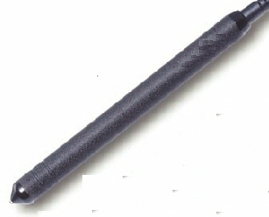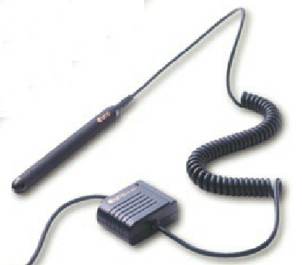
OPTICAL
Resolution 0.1mm, 0.15mm
Depth of Field 0.6mm/0.15mm Width
Light Source Red/660nm, IR/940nm
Scanning Speed 50-500mm/sec.
Scanning Angle 10°- 40° (From Vertical)
ELECTRICAL
Input Power 5V DC ± 5%
Power Consumption 4mA for Low Power
16mA as standard
PHYSICAL
Cable Coil/Straight
Body Metal
Color Black Metal
Connector DB9 F/M, AMP Squeeze
Scanner Tip Field Replaceable Sapphire Tip
ENVIRONMENT
Operating Temperature O°C to 40°C (32°F - 104°F)
Storage Temperature -20°C to 60°C (-4°F - 140°F)
Relative Humidity 20% to 85% (Non-Condensing)

